**Week 1~2**

**Lab: Array Communications & Processing**

**Name: Chenhao Wang**

**CID: 02252927**

**Task 1:**

图表

The best direction is 90 degrees and the gain is 6.99 dB .

*Code*:

array=[-2 0 0; -1 0 0; 0 0 0; 1 0 0; 2 0 0];

directions=[30,0; 35,0; 90,0];

%% task1

Z=pattern1(array);

figure(1)

plot2d3d(Z,0:180,0,'gain in dB','initial pattern');

**Task 2**

Three sources are uncorrelated and of equal powers, meaning the covariance matrix Rmm is a 3*3 unity matrix.

$$R_{mm}=\left[\begin{matrix}1 & 0 & 0 \\ 0 & 1 & 0 \\ 0 & 0 & 1\end{matrix}\right]$$

Rxx_theoretical is a 5-rank square matrix with complex elements. If the geometry of the matrix changes, the S will change but still be a 5*5 matrix. So, the form of the Rxx_theoretical will not change.

*Code*:

%% task2

S=spv(array,directions);

Rmm=eye(3,3); % (A,A) (B,B) (C,C) are 1, others are 0

sigma2=0.0001;

Rxx_theoretical=S*Rmm*S'+sigma2*eye(5,5);

**Task 3**

The audio is a little noisy overlapped with several different parts together and the picture looks like different layers of pictures overlapping each other.

*Code*:

%% task 3

load Xaudio.mat;

load Ximage.mat;

soundsc(real(X_au(2,:)),11025);

displayimage(X_im(2,:),image_size,201,'The received signal at 2nd antenna');

Rxx_au=X_au*X_au'/length(X_au(1,:));

Rxx_im=X_im*X_im'/length(X_im(1,:));

**Task 4**

*Code*:

%% task 4

directions=[];

Rmm=[];

S=[];

sigma2=[];

**Task 5**

**5.1.**

The values of the first two elements are very small, and they are equal to the set sigma which represents the value of the added noise with a power of -40dB (0.0001). Then, there are 3 rows left which present that there are 3 sources.

**5.2.** The eigenvalue got is the diagram of the Rxx matrix and its elements could be listed below. The elements are consists of elements represents signals and noise respectively.

“P27. 4_ACT_Array Receivers_SIMO_MIMO_2019, A.Manikas”[1]

**5.3.**

文本

They also show that there should be 3 signals and the power of the noise are quite small which is close to 0.

*Code*:

%% task 5

val_theo=eig(Rxx_theoretical);

val_au=eig(Rxx_au); val_im=eig(Rxx_im);

**Task 6**

Set gain factor a to be 1 and the wopt is

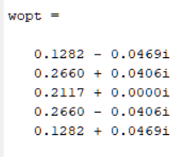

Hence the Wiener-Hopf array pattern is

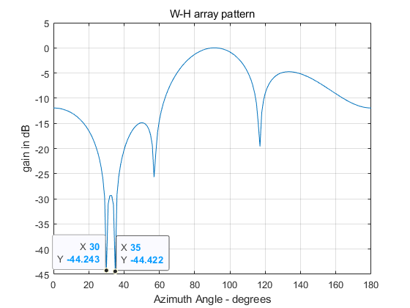 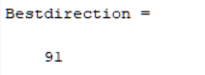

It illustrates clearly that there are two other interferences at the angle of 30 and 35 degrees.

*Code*:

%% task 6

Sd=spv(array,[90,0]);

a=1;

wopt=a*Rxx_theoretical\Sd;%inv(Rxx_theoretical)*Sd

Z=pattern1(array, wopt);

plot2d3d(Z, 0:180,0,'gain in dB','W-H array pattern');

**Task 7**

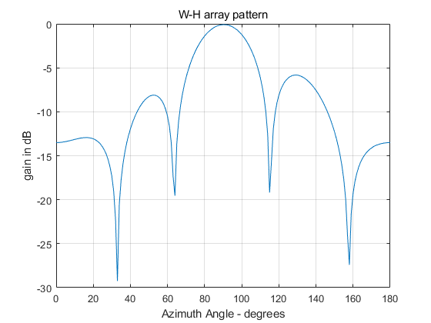

When changing the noise to 10dB (sigma2=0.1), interferences could not be distinguished. The shape is likely to be the initial pattern.

*Code*:

%% task 7

%theoreical cal

array=[-2 0 0; -1 0 0; 0 0 0; 1 0 0; 2 0 0];

directions=[30,0; 35,0; 90,0];

%task 2

S=spv(array,directions);

Rmm=eye(3,3); % (A,A) (B,B) (C,C) are 1, others are 0

sigma2=0.1;

Rxx_theoretical=S*Rmm*S'+sigma2*eye(5,5);

%task3

load Xaudio.mat;

load Ximage.mat;

soundsc(real(X_au(2,:)),11025);

displayimage(X_im(2,:),image_size,201,'The received signal at 2nd antenna');

Rxx_au=X_au*X_au'/length(X_au(1,:));

Rxx_im=X_im*X_im'/length(X_im(1,:));

%task4

Rmm=[];

S=[];

directions=[];

sigma2=[];

%task5

val_theo=eig(Rxx_theoretical);

val_au=eig(Rxx_au); val_im=eig(Rxx_im);

[E,D]=eig(Rxx_au);

%task6

Sd=spv(array,[90,0]);

a=1;

wopt=a*Rxx_theoretical\Sd;%inv(Rxx_theoretical)*Sd

Z=pattern1(array, wopt);

plot2d3d(Z, 0:180,0,'gain in dB','W-H array pattern');

**Task 8**

When only one direction of the signal is sure, the Wiener-Hopf array pattern is affected greatly by the power of the noise. If the noise is smaller than -40dB, the interferences could be distinguished easily and clearly.

**Task 9&10**

1. **Algorithm**

According to the algorithm introduced in [2], the MATLAB function music could be written as:

function [Pmu_lg,P]=music(array,Rxx,M)

%algorism of Multiple Signal Classification (MUSIC)

%calculate covariance Rxx using practical method

%% main function

[E,D]=eig(Rxx); %E:eigenvectors, D: eigenvalues

%sort eigenvectors according to diagram of eigenvalues from large to small

[d,idx]=sort(diag(D),'descend');

% Ds=D(idx,idx);

E=E(:,idx);

[N,N1]=size(Rxx);

%get noise subspace

% En=E(:,M+1:N);

%fpoc:complement projection operator of A(Pn)

%P_n =I_N-P_Es, P_Es=Es*inv(Es'*Es)*Es';(Es: sorted eigenvectors)

En=E(:,M+1:N);

Es=E(:,1:M);

Pn=fpoc(Es); % Pn=eig(N)-PEs;

for angle=1:181

direction=[angle-1,0];

S=spv(array,direction);

Pmu(angle)=1/(S'*Pn*S);

% Pmu(angle)=1/(S'*En*(En')*S);

end

Pmu=abs(Pmu);

Pmu_max=max(Pmu);%arg_M_min;

Pmu_lg=10*log10(Pmu);

P=10*log10(Pmu/Pmu_max);

1. **Task9:**

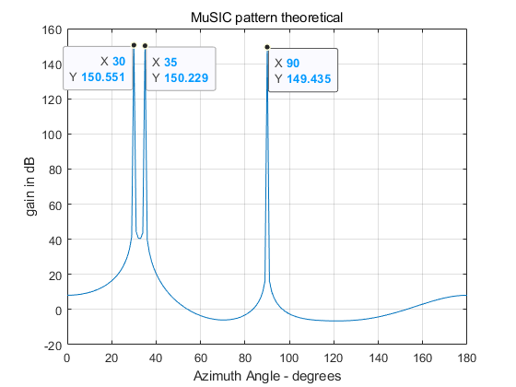

There are 3 sources at directions 30, 35 and 90 degrees.

1. Task 10

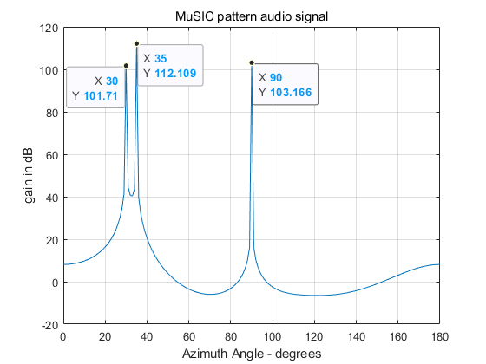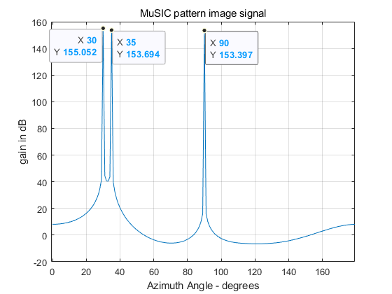

From the figures above, 3 interferences(sources) at directions 30,35 and 90 degrees are clearly illustrated.

*Code:*

%% task 9&10&11

%basic parameters

array=[-2 0 0; -1 0 0; 0 0 0; 1 0 0; 2 0 0];

M=3; %number of signal (known)

%% task9 music_theoretical

directions=[30,0; 35,0; 90,0];

S=spv(array,directions);

Rmm=eye(3,3); % (A,A) (B,B) (C,C) are 1, others are 0

sigma2=0.0001;

Rxx_theoretical=S*Rmm*S'+sigma2*eye(5,5);

[Pmusic_theo,Ptheo]=music(array, Rxx_theoretical,M);

plot2d3d(Pmusic_theo,0:180,0,'gain in dB','MuSIC pattern theoretical');

%% task10 music_audio

load Xaudio.mat;

load Ximage.mat;

% soundsc(real(X_au(2,:)),11025);

% displayimage(X_im(2,:),image_size,201,'The received signal at 2nd antenna');

Rxx_au=X_au*X_au'/length(X_au(1,:));

[Pmusic_au,Pau]=music(array,Rxx_au,M);

plot2d3d(Pmusic_au,0:180,0,'gain in dB','MuSIC pattern audio signal');

%% task10 music_image

Rxx_im=X_im*X_im'/length(X_im(1,:));

[Pmusic_im,Pim]=music(array,Rxx_im,M);

plot2d3d(Pmusic_im,0:180,0,'gain in dB','MuSIC pattern image signal');

%% task11_part1 1&2 signals are fully correlated

Rmm=[1,1,0;1,1,0;0,0,1]; %sources from 30 and 35 degrees fully correlated

Rxx_coherent=S*Rmm*S'+sigma2*eye(5,5);

[Pmusic_coherent,Pcoh]=music(array, Rxx_coherent,M);

plot2d3d(Pmusic_coherent,0:180,0,'gain in dB','MuSIC pattern fully correlated');

Task 11

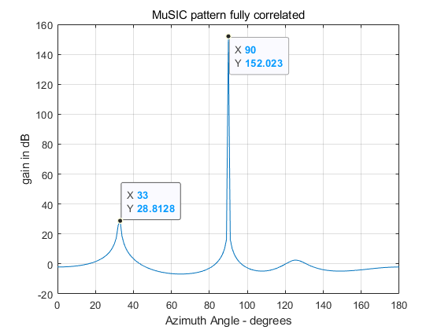

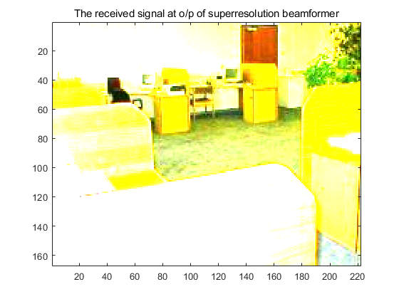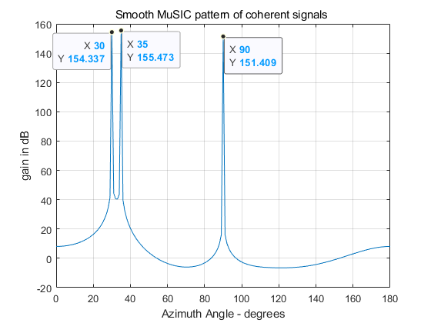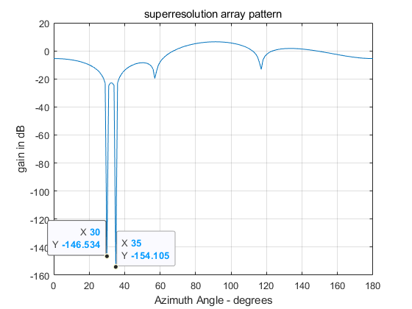

%% task11_part1 1&2 signals are fully correlated

Rmm=[1,1,0;1,1,0;0,0,1]; %sources from 30 and 35 degrees fully correlated

Rxx_coherent=S*Rmm*S'+sigma2*eye(5,5);

[Pmusic_coherent,Pcoh]=music(array, Rxx_coherent,M);

plot2d3d(Pmusic_coherent,0:180,0,'gain in dB','MuSIC pattern fully correlated');

%% task11_part2 smooth

Rbar=smooth(array,Rmm,S);

Rxx_smooth=S*Rbar*S'+sigma2*eye(5,5);

[Psmooth,Pcoh]=music(array, Rxx_smooth,3);

plot2d3d(Psmooth,0:180,0,'gain in dB','Smooth MuSIC pattern of coherent signals ');

%% task12 superresolution beamformer

%part1 au

Sd=spv(array,[90,0]); %Sdisire

wopt1=Rxx_au\Sd;

yt1=wopt'*X_au;

soundsc(real(yt1),11025);

%task2

wopt2=Rxx_im\Sd;

yt2=wopt2'*X_im;

displayimage(yt2, image_size, 202,'The received signal at o/p of W-Hbeamformer');

%task3

Sj=S(:,1:2); %

% Sj=spv(array,[30,0;35,0]);

wopt3=fpoc(Sj)*Sd;

yt3=wopt3'*X_im;

displayimage(yt3, image_size, 202,'The received signal at o/p of superresolution beamformer');

Z=pattern1(array, wopt3);

plot2d3d(Z, 0:180,0,'gain in dB','superresolution array pattern');

**References:**

1. 4_ACT_Array Receivers_SIMO_MIMO_2019, A. Manikas
2. Schmidt R.O., "Multiple Emitter Location and Signal Parameter Estimation", IEEE Transactions on Antennas and Propagation, Vol. AP-34, No.3, pp 276-280, March 1986
3. Shan T., Wax M., Kailath T., "On Spatial Smoothing for Direction-of-Arrival Estimation of Coherent Signals", IEEE Transactions on Acoustics, Speech and Signal Processing, Vol. ASSP-33, No.4, pp 806-811, August 1985.